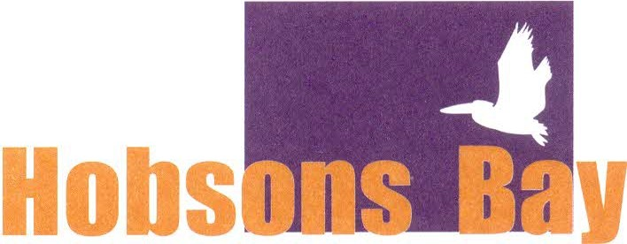

Community Advancement Co-Operative Ltd

Hobsons Bay Community Advancement Co-operative Ltd

**2024-2025 Annual Membership**

Annual Membership Fee: $20.00 (includes GST)

**Member Details:**

|  |  |  |
| --- | --- | --- |
| Surname: Click here to enter text. | Given name: Click here to enter text. | |
| Address: Click here to enter text. | | |
| Click here to enter text. | | Postcode: Click here to enter text. |
| Phone: Click here to enter text. | | |
| Email: Click here to enter text. | | |

**Payment Method**

Cash or Credit Card (in person)

Louis Joel Arts & Community, 5 Sargood Street, Altona

9.30 – 4.30pm Monday – Friday, or

11am – 2pm Saturday & Sunday

**Direct Payment Details**

Bendigo Bank

BSB: 633000

Account Number: 123848954

Account Name: Hobsons Bay Community Advancement Co-operative Ltd

Reference: Your Surname and initial

***Please email a copy of your deposit receipt to*** [***admin@ljac.com.au***](mailto:admin@ljac.com.au)